 | GREEN ALGAE
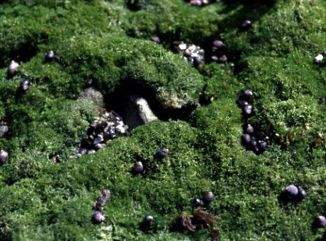  Cladophora | 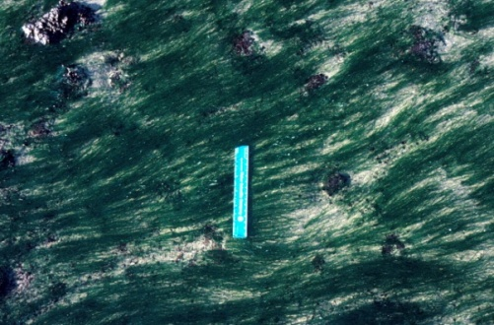  Chaetomorpha | 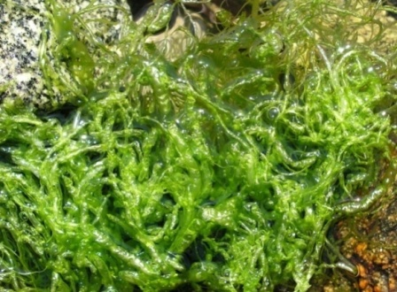  Ulva (=Enteromorpha)
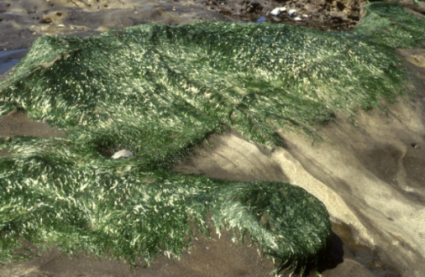  Ulva [sea lettuce] | 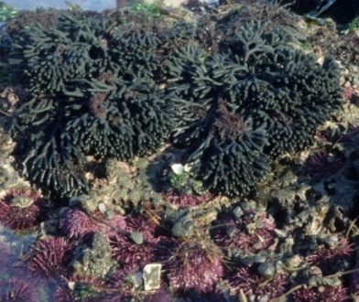  Codium fragile [sea staghorn] | 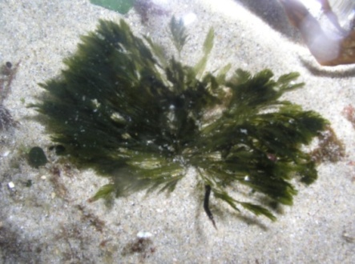  Bryopsis
 | © C.D. Trowbridge 2009
 | BROWN ALGAE
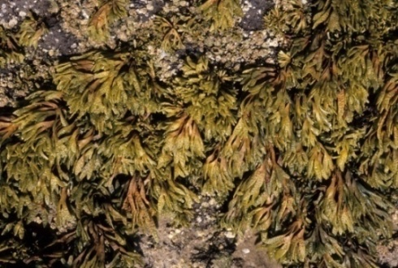  Pelvetiopsis [rockweed] | 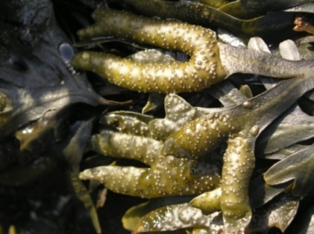  Fucus [rockweed] | 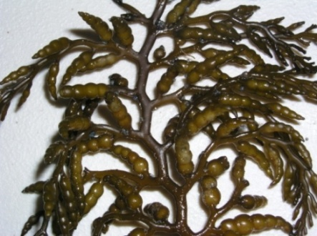  Cystoseira
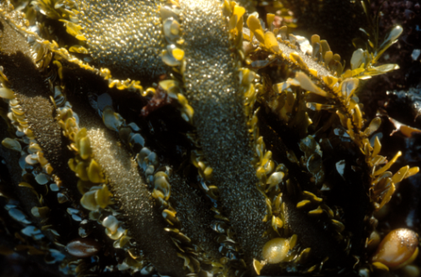  Egregia [feather boa kelp] | 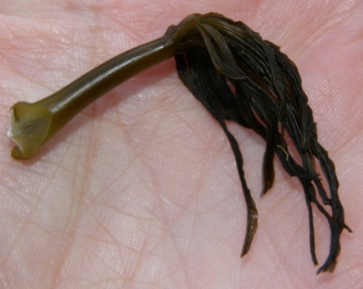  Postelsia [sea palm kelp] | 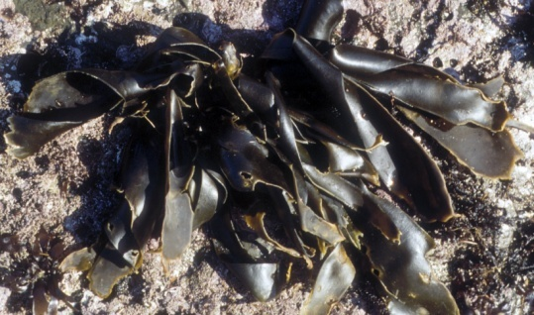  Saccharina (=Hedophyllum)  [cabbage kelp]
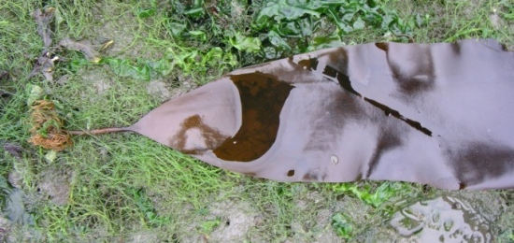  Saccharina (=Laminaria) [sugar kelp] | 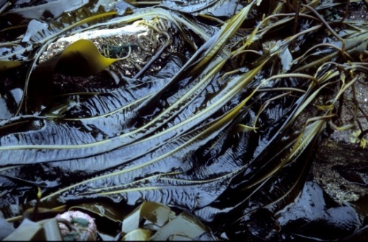  Alaria [feather kelp] | 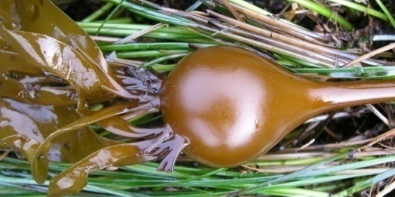  Nereocystis [bull kelp]
 | RED ALGAE
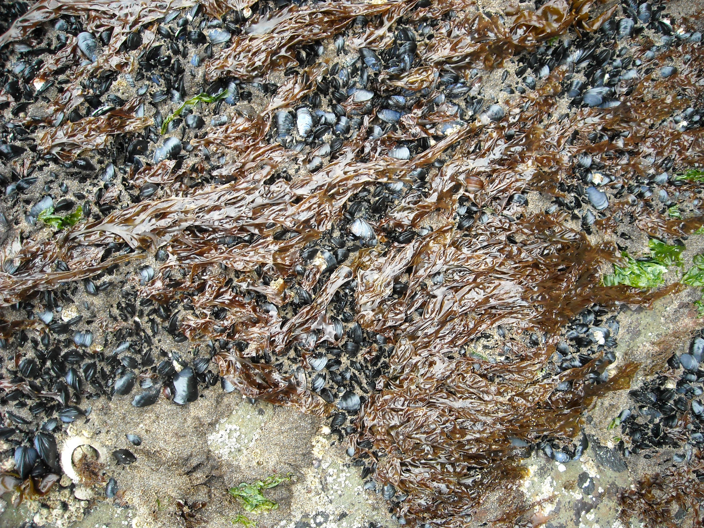  Porphyra [nori] | 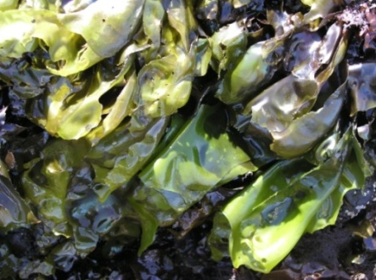  Mazzaella (=Iridaea) | 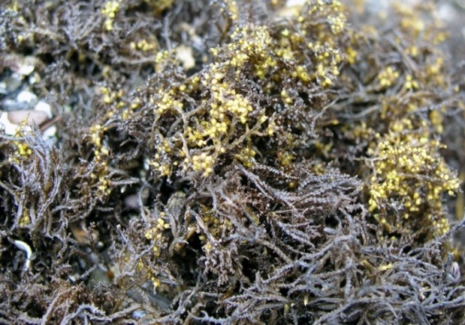  Endocladia [pot scrubber alga]
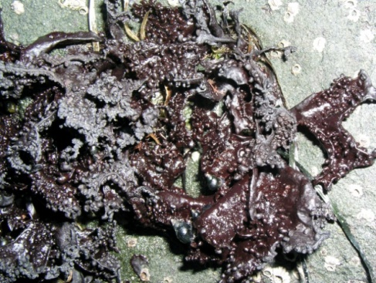  Mastocarpus | 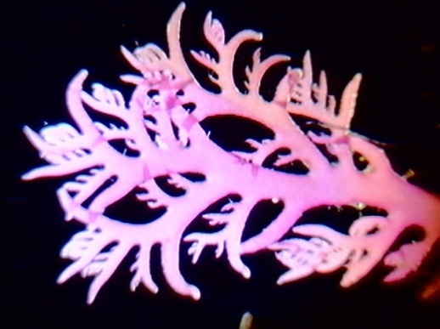  Plocamium | 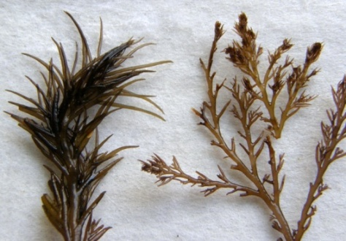  Odonthlia
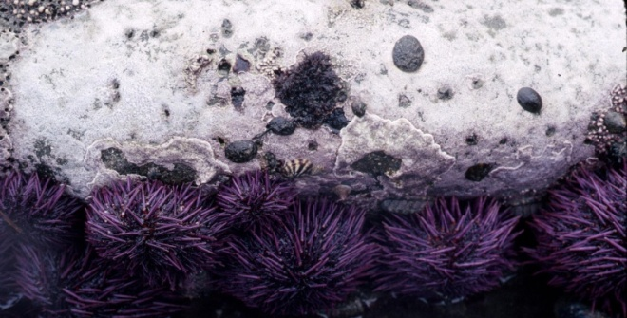  encrusting coralline | 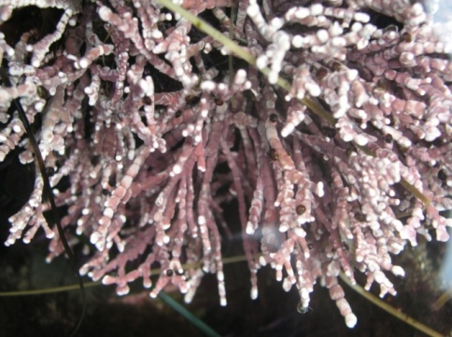  upright, branching coralline | 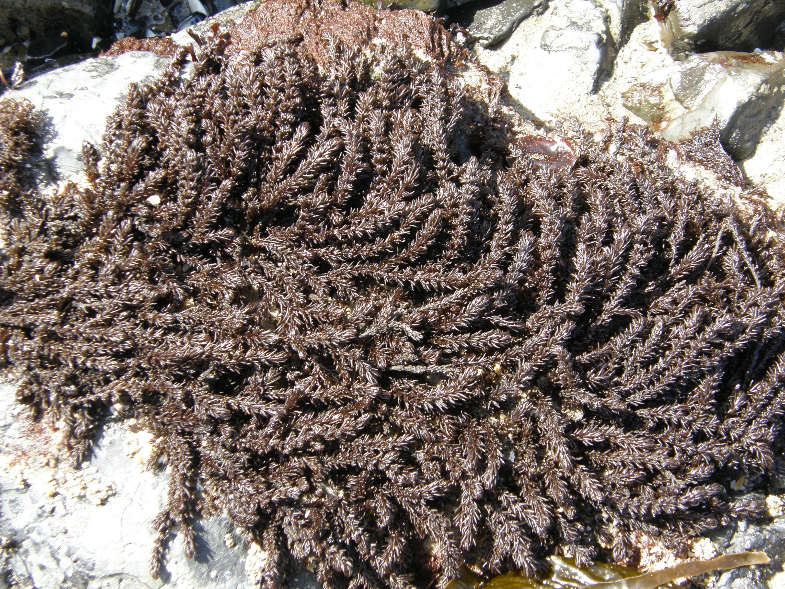  Neorhodomela [black pine]
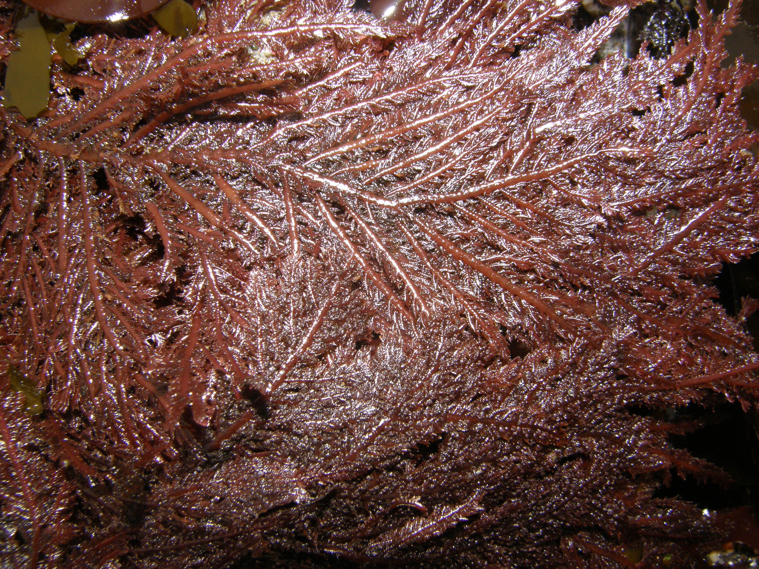  Neoptilota/Ptilota | 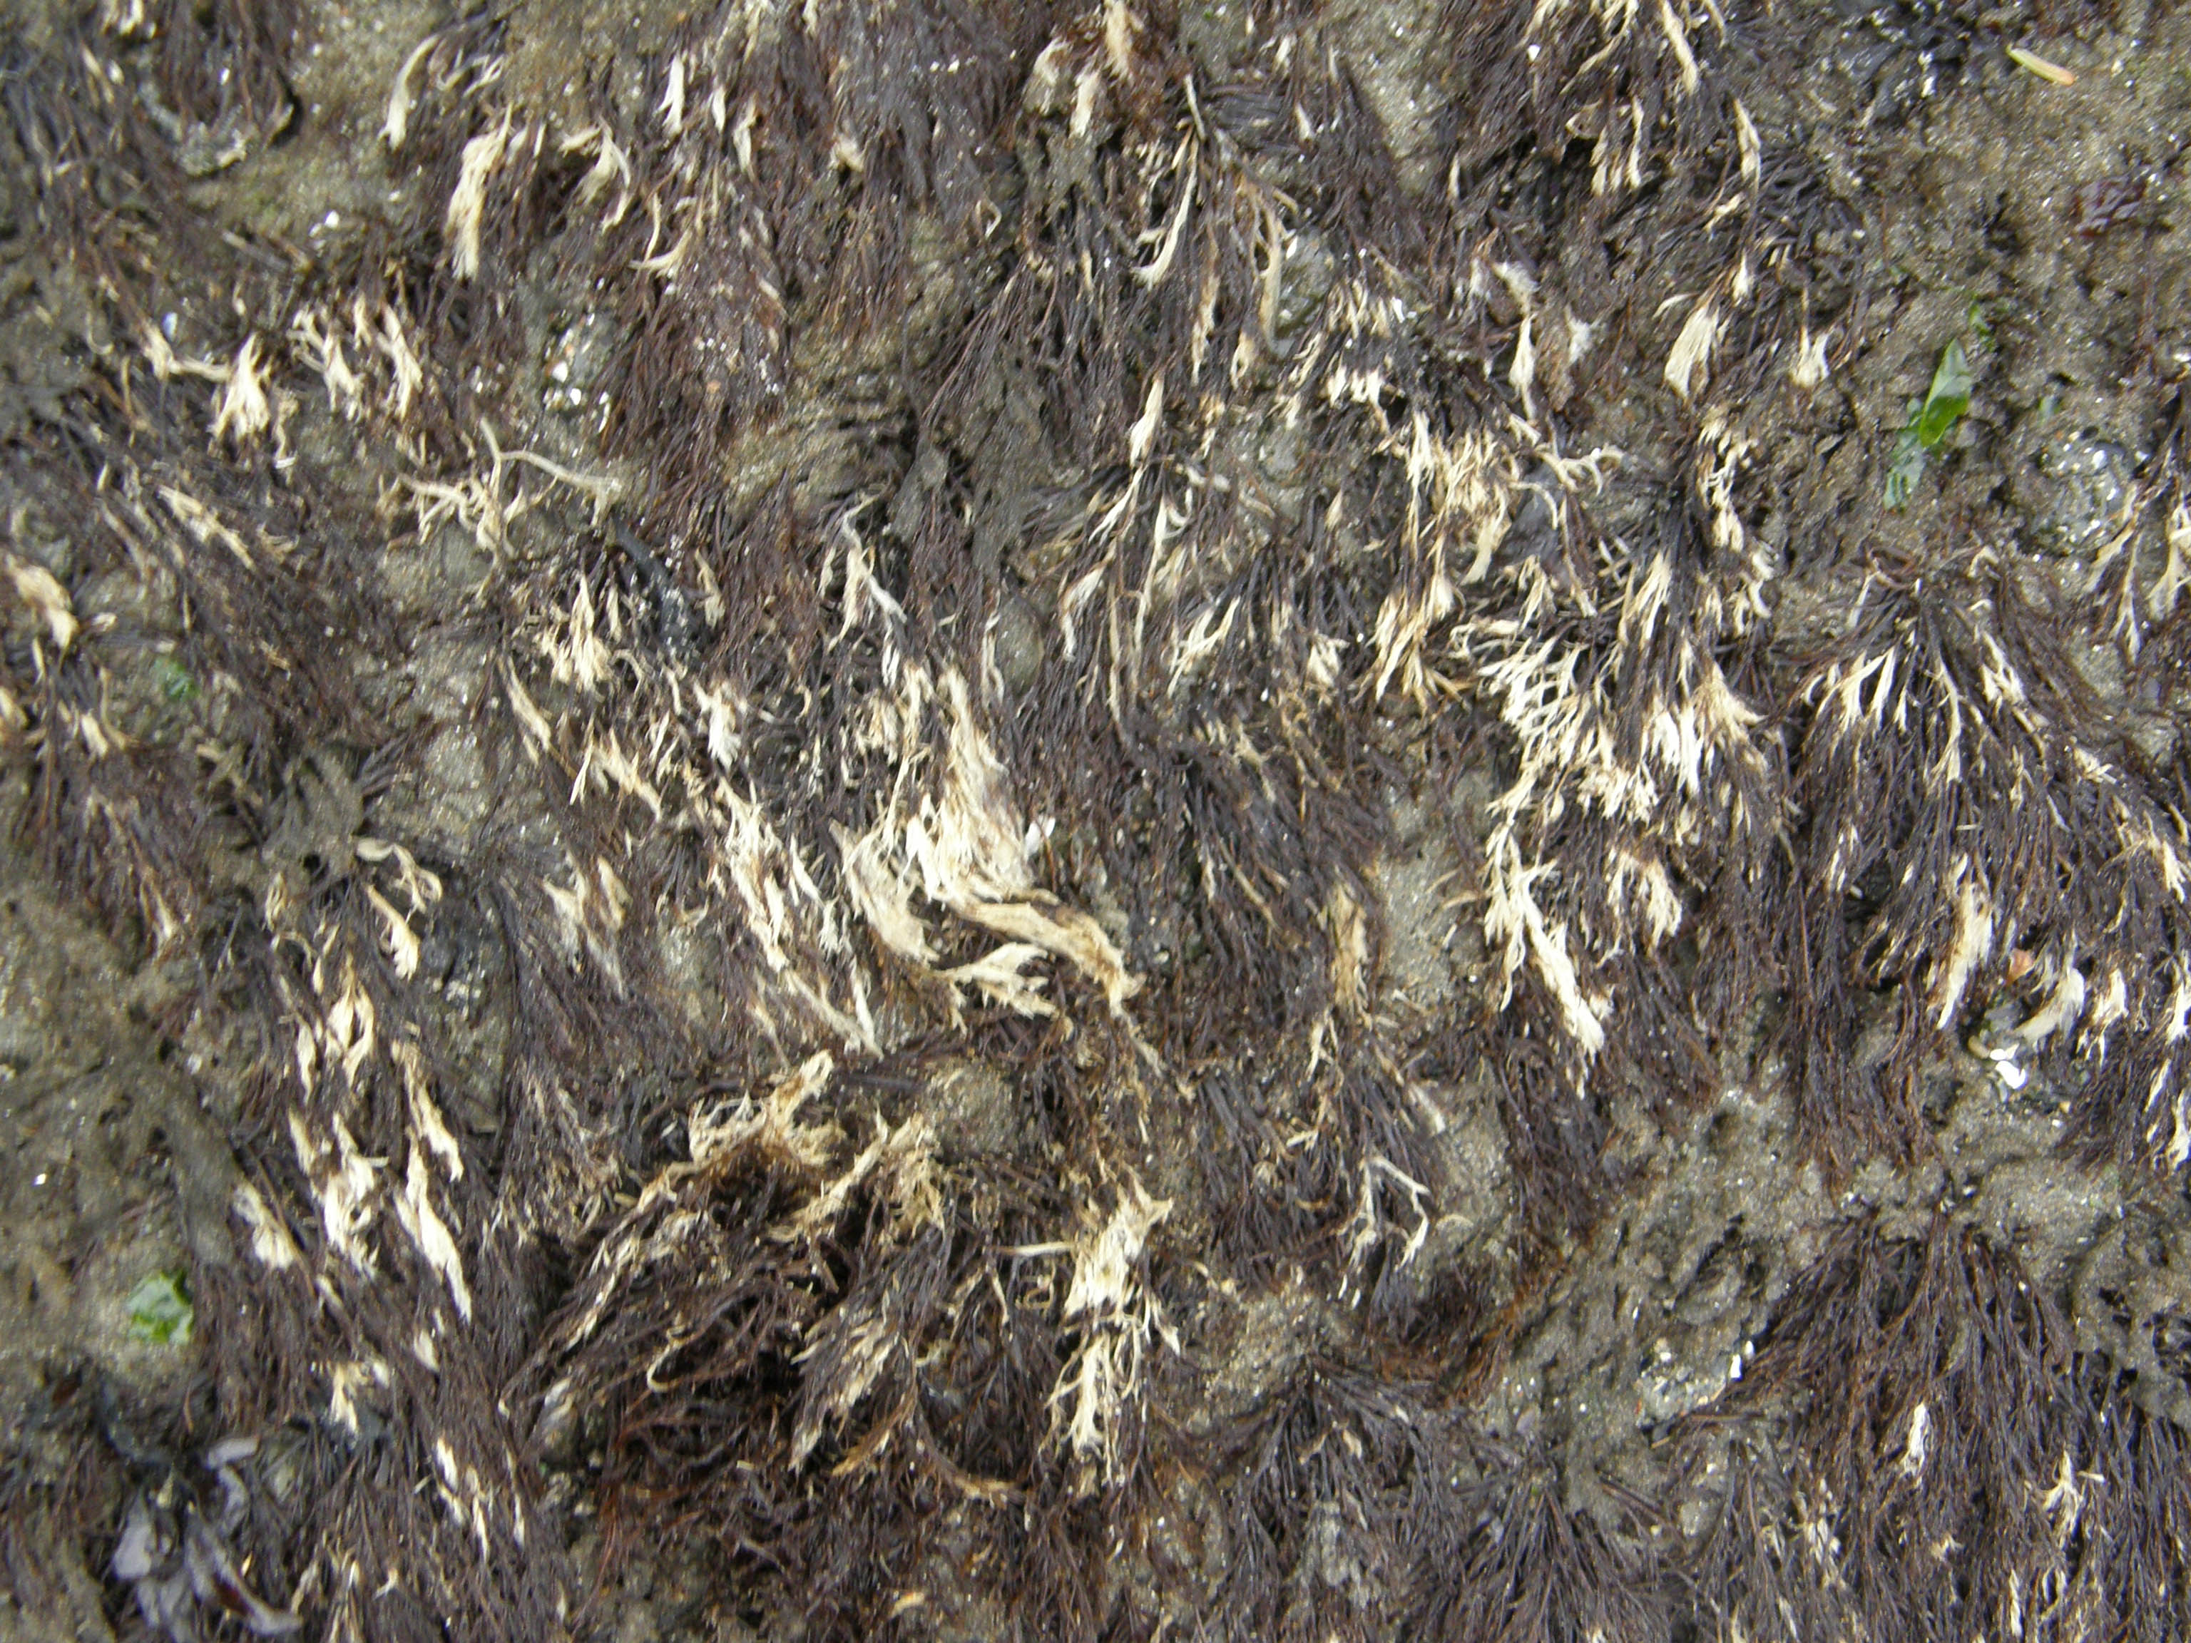  Cryptosiphonia | 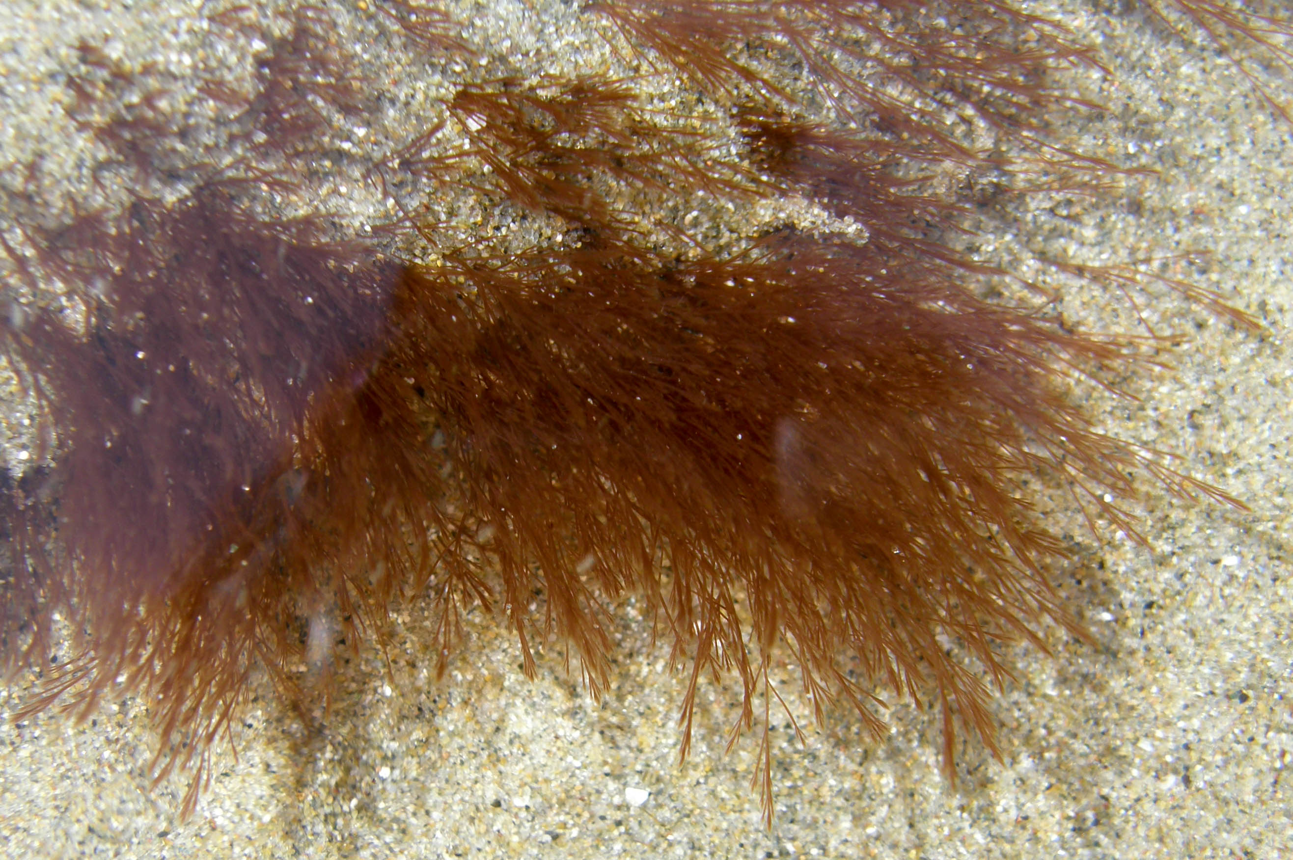  Polysiphonia
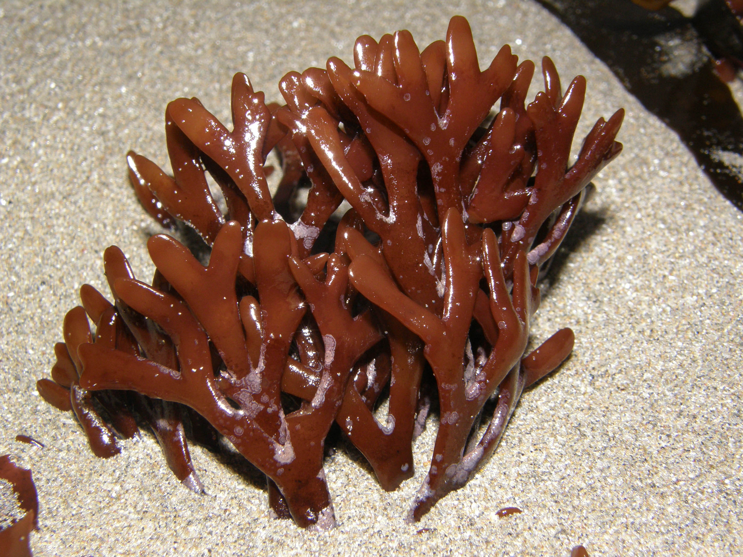  Ahnfeltiopsis | 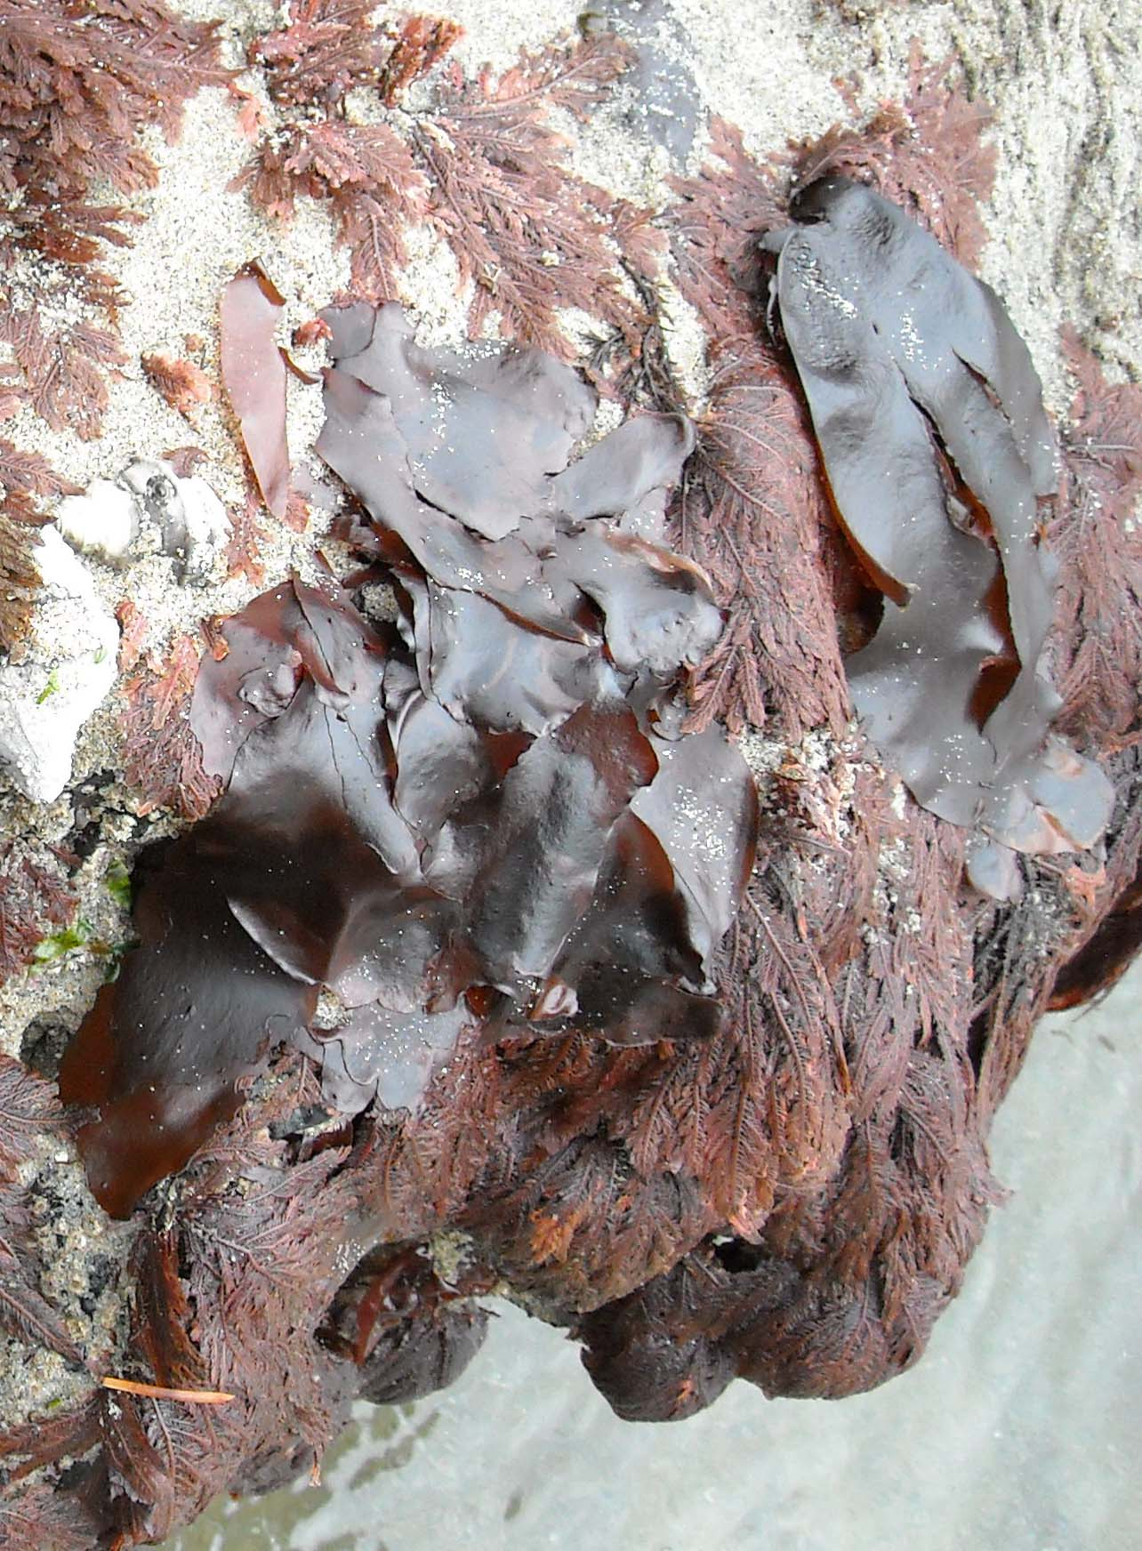  Dilsea [red blade] | 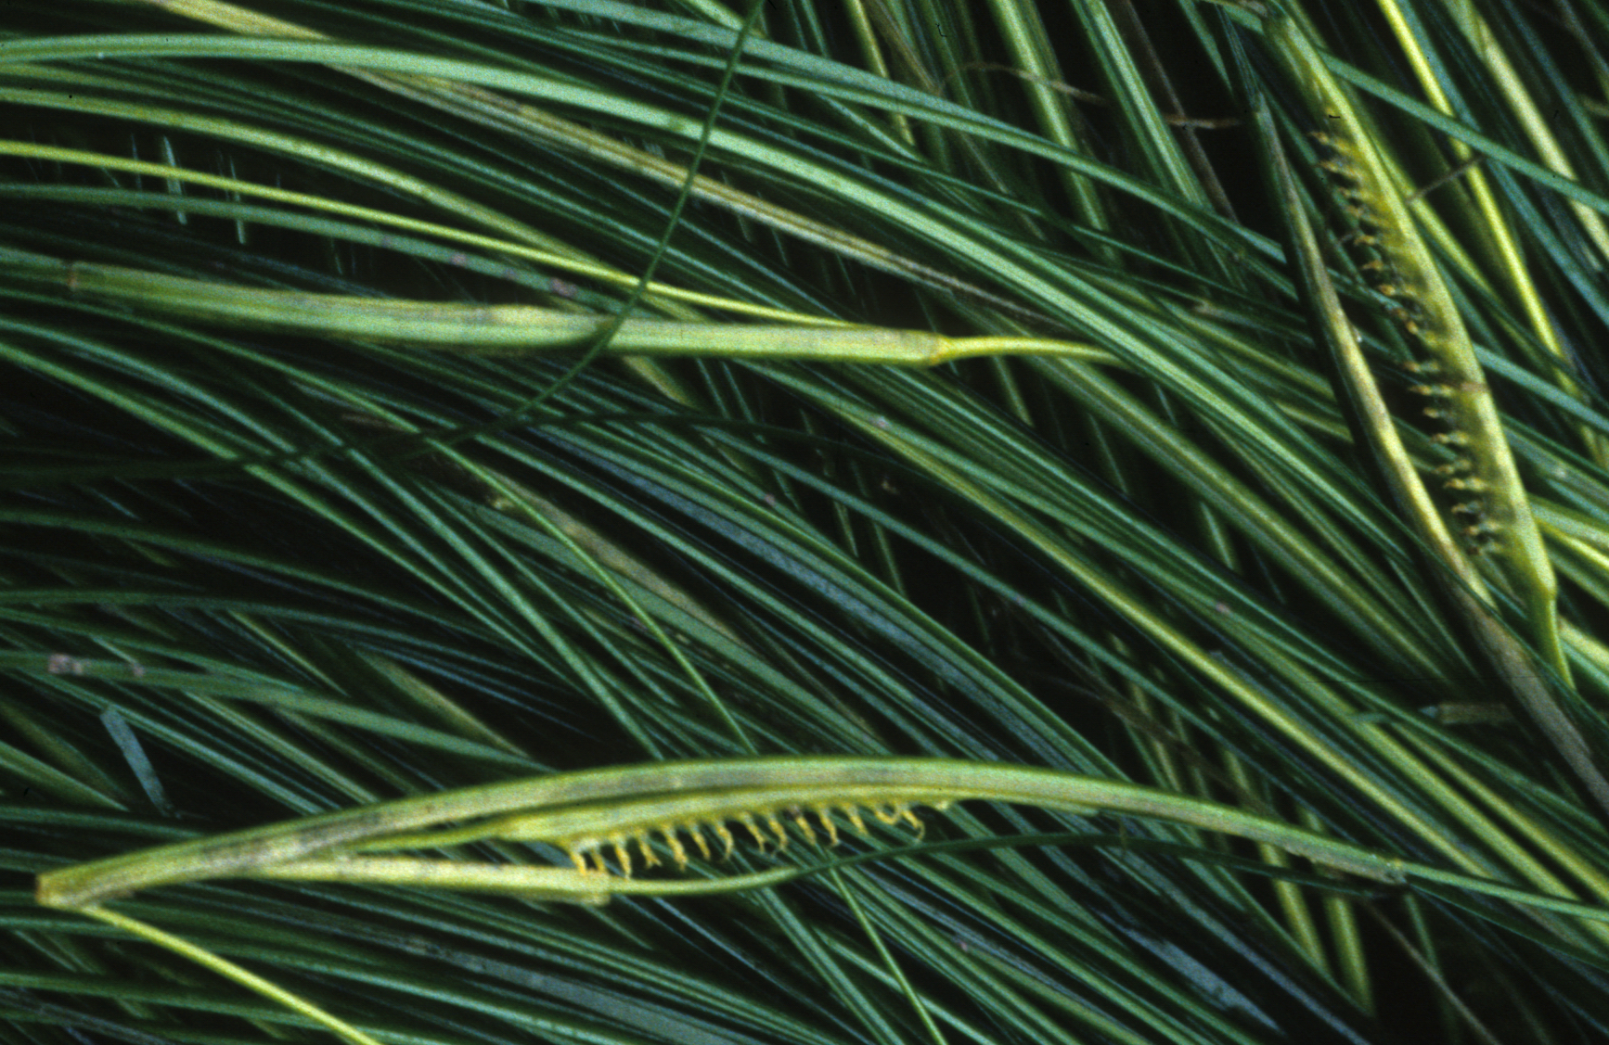  Phyllospadix  [surfgrass: vascular plant]

